

***BONE AND JOINT MULTISPECIALTY HOSPITAL***

***9-A-30, RC Vyas colony, Bhilwara-311001***

**HOSPITAL PROFILE**

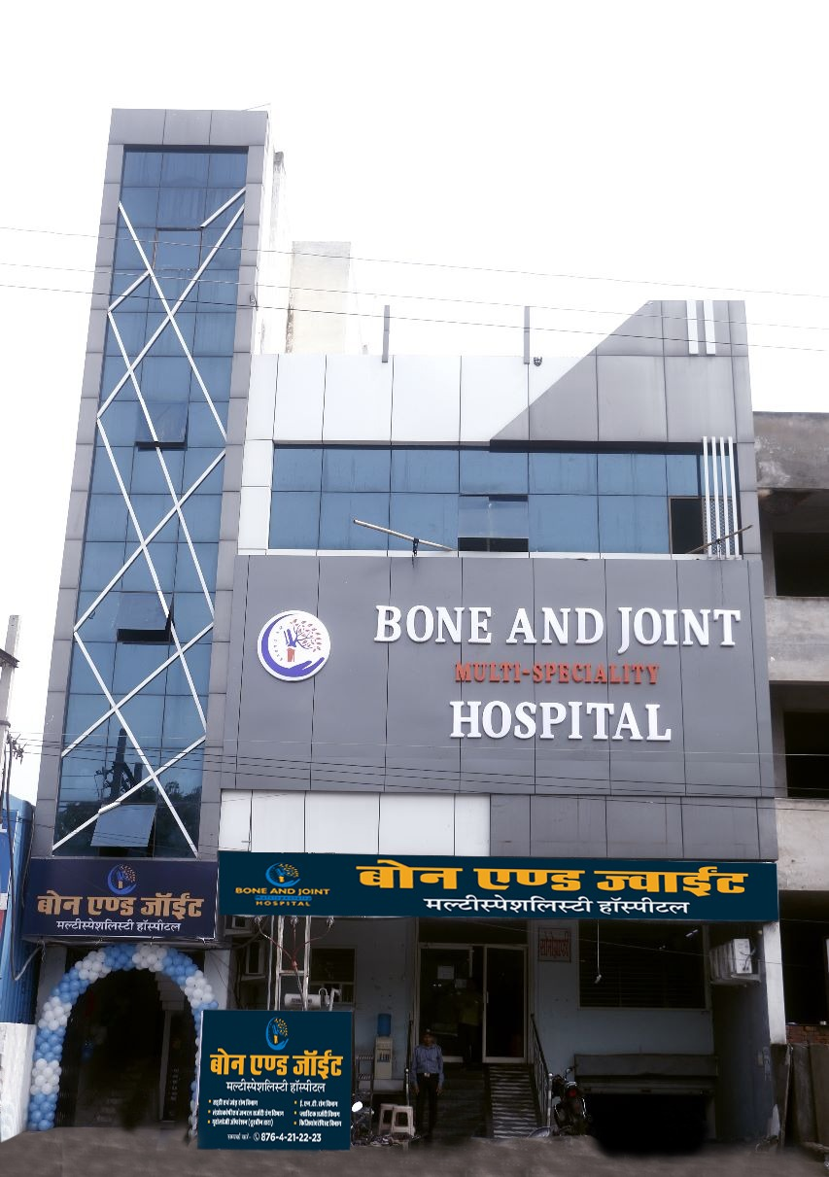

**BONE AND JOINT MULTISPECIALTY HOSPITAL**

Is a state of art facility covering the full gamut of dedicated advanced orthopedics surgery, plastic surgery and general surgery ailments; right from surgery to rehabilitation catering to all age groups. We combine wisdom and formidable experience with advanced technology and evidence-driven therapies to deliver the highest level of patient care and satisfaction.

*With our vision to offer the finest hospital infrastructure and provide unsurpassed patient care****, BONE AND JOINT MULTISPECIALTY HOSPITAL*** *embodies the best hospital building norms and incorporates the best medical protocols. We hope to strive and deliver state of art and class medical and surgical services. Cleanliness and hospital Infection control are the most important priorities of a hospital, and in bone and joint multispecialty hospital we hope to exceed most of those norms all with* ***SHARP*** *precision.*

**S** – Sympathy

**H** – Honesty

**A**- All Together

**R** – Regular earning

**P**- Precision

With our aim being compassion with care, we are relentless in our pursuit to make quality healthcare affordable and accessible for all. Our hospital is committed to provide efficient, effective and user-friendly healthcare services to its patients, through best medical practices in a clean, healthy and rejuvenating environment.

## OUR VISION

To attain the goal of providing round the clock state of art care to one and all irrespective of class, creed or religion.

## OUR MISSION

Providing high class facilities in Orthopedic, General Surgery and other super specialty services to the people at door step at most affordable cost. In nutshell our motto and mission is to serve the humanity with full perfection.

* To create a patient-centric tertiary healthcare organization focused on non-intrusive quality care utilizing leading edge technology with a human touch.
* Achieve professional excellence in delivering quality care.
* Push frontiers of care through research and education.
* Adhere to national and global standards in healthcare.
* Ensure care with integrity and ethics.
* Provide quality healthcare to all sections of society.

# EXPECTATION FROM HOSPITAL

* Good Medical Care
* Good Nursing Care
* Less Waiting Time
* Excellent Hospitality
* Personal Attention
* Courteous Behavior
* Affordable Charges
* Cleanliness
* Good Coordination
* Cooperation among the Staff
* Discipline
* Communication & Information
* Transparency in charges and procedures

# FACILITIES AND SERVICE

# Orthopedic surgery

* 24x7 hospital Ambulance
* Digital X-Ray, Laboratory
* A.C. Super Deluxe Rooms
* In house Pharmacy

# VALUE ADDED SERVICES

* + Helpdesk, Pharmacy, Laundry, Parking facilities.
  + 24 x 7 Emergency Services, well equipped casualty & Ambulance services.
  + Patient care executive to help and address all the quarries.
  + Hospital information system for regular billing updates.
  + Separate and specious wards with pleasing ambience, comfortable waiting area.
  + Food facility for inpatients, Comfortable and Hygienic health care facilities.
  + Efficient, Friendly and competent paramedical personnel.
  + Post-surgical patient care facilities.

## CORPORATE PATIENT FACILITY

* + - Health Check-ups
    - Outpatient Facilities
    - Inpatients Facilities
    - Screening camps
    - Awareness seminars/Doctor`s talk
    - Health and wellness workshops
    - Pick up and Drop facilities
    - Room reservation for VIP guest
    - 24 hours ambulance and pharmacy service and many more
    - Online consultation of specific doctor.

# BUILDING OVERVIEW

## GROUND FLOOR

* + X-RAY DEPT.
  + LABORATORY

## FIRST FLOOR

* + RECEPTION
  + OPD CONSULTING CHAMBERS
  + EMERGENCY DEPT.
  + PHARMACY
  + OPERATION THEATRES
  + AUTOCLAVE ROOM
  + DELUX ROOM
  + ACCOUNTS
  + AC WARD

**SECOND FLOOR**

* GENERAL WARD MALE/FEMALE
* PRIVATE ROOMS NON-AC
* STAFF CHANGING ROOM
* PHYSIOTHERAPY ROOM
* STORE ROOM

**The Hospital has the following special features as its areas of excellence.**

**Diagnostic Services**

* X-RAY
* PATHOLOGICAL LAB

**Infrastructure details:**

|  |  |
| --- | --- |
|  |  |
| * General Ward | 02 |
| * Deluxe Room | 03 |
| * Semi Deluxe * AC Ward | 02  01 |
| * OT | 02 |
| * Emergency | 01 |
| * OPD Rooms * Physiotherapy 01 | 02  01 |
|  |  |
|  |  |

|  |  |  |  |
| --- | --- | --- | --- |
| **s.no.** | **SPECIALTY** | **DOCTOR’S NAME** | **OPD TIMINGS** |
| **1** | **Orthopaedics & Joint Replacement** | **Dr. Arun Dungarwal** | **10 AM-07 PM** |  |  |  |
| **2** | **Anesthesia** | **Dr. Ajay Garg** | **On call** |
| **3** | **Physiotherapy** | **Dr Harsh Bafna** | **10 AM-07 PM** |
| **4** | **General surgeon** | **Dr Dinesh Gupta** | **On call** |
| **5** | **Plastic surgeon** | **Dr Akhil Chauhan** | **On call** |

**Our Team:**

* Mr. Pradeep Gadri: Administrator
* Mrs. Alka Sen: Nursing Sup.
* Mr. Manish Lakhara: In-charge Marketing
* Mr. Devraj Gurjar: In-charge Emergency
* Mr. Azhar: In-charge O T
* Miss Pooja: Receptionist

**Joint responsibility for both sites:**

* Dr. Arun Dungarwal: Director / Chief surgeon
* Mr. Anil Dhakar: Human Resource Management
* Mrs. Rajat Laddha: Account management

**Contact Details**

|  |  |  |  |
| --- | --- | --- | --- |
| **S. No.** | **Name** | **Designation** | **Contact No.** |
| 1 | Dr. ARUN DUNGARWAL | **Director/Chief surgeon** | 9680825776 |
| 2 | Mr. Pradeep Gadri | Administrator | 8107177661 |
| 3 | Mr. Rajat Laddha | Accounts In-charge | 8446985923 |
| 4 | Miss. Pooja | Receptionist | 8764212223 |
| 5 | Mr. Manish Lakhara | In-charge Marketing | 9672544067 |